**Elastic Beanstalk – Deploy an application**

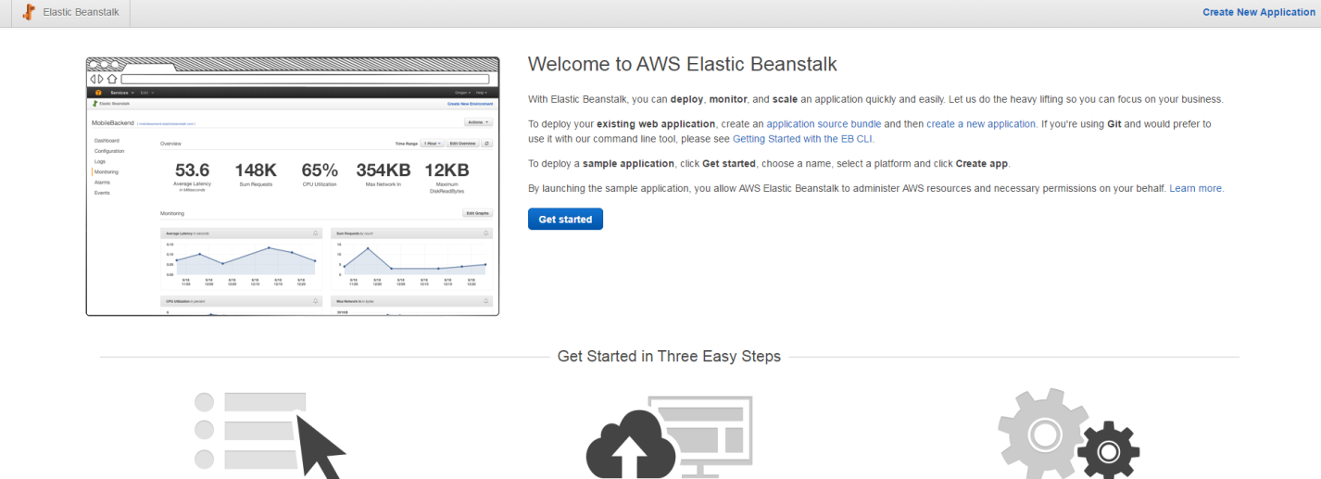

**Click get started**

**Set the application name and choose the platform**

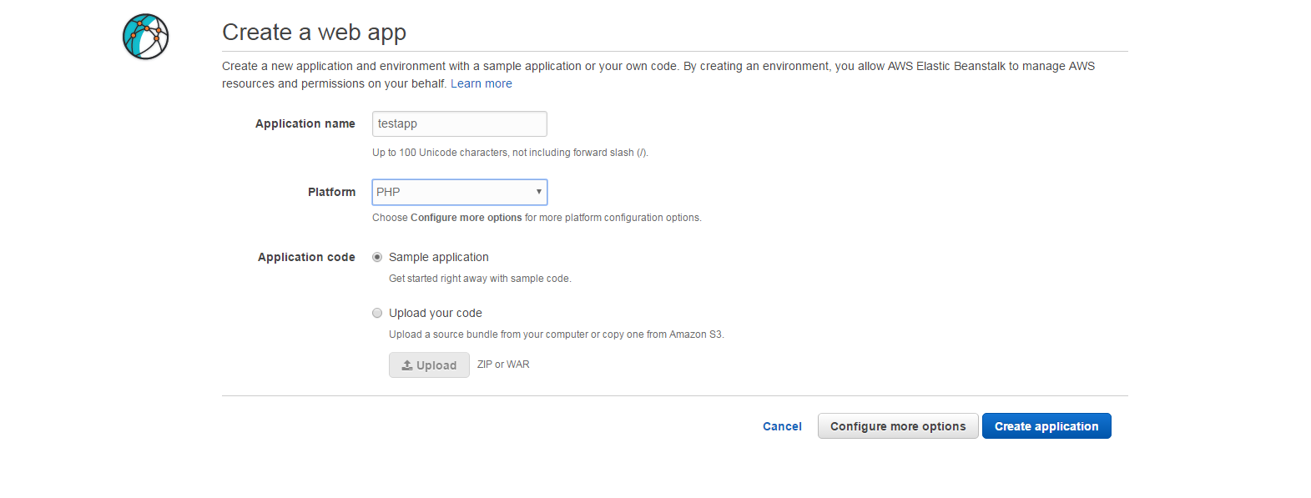

**Click Create applications**

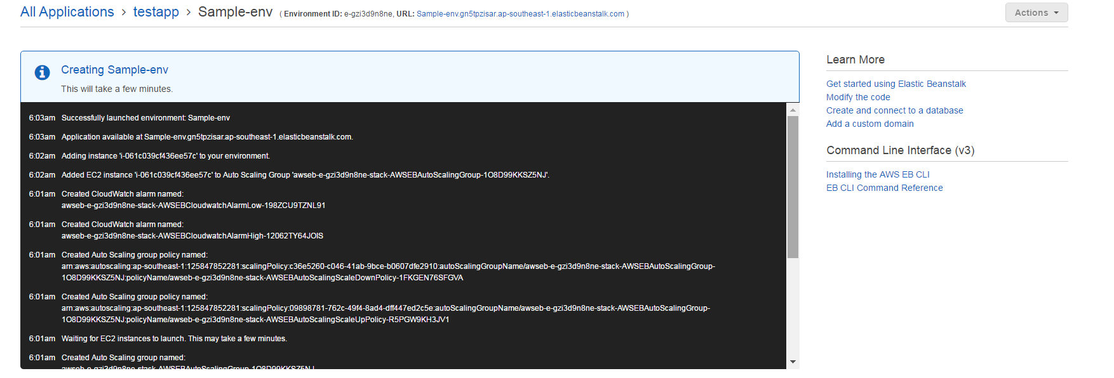

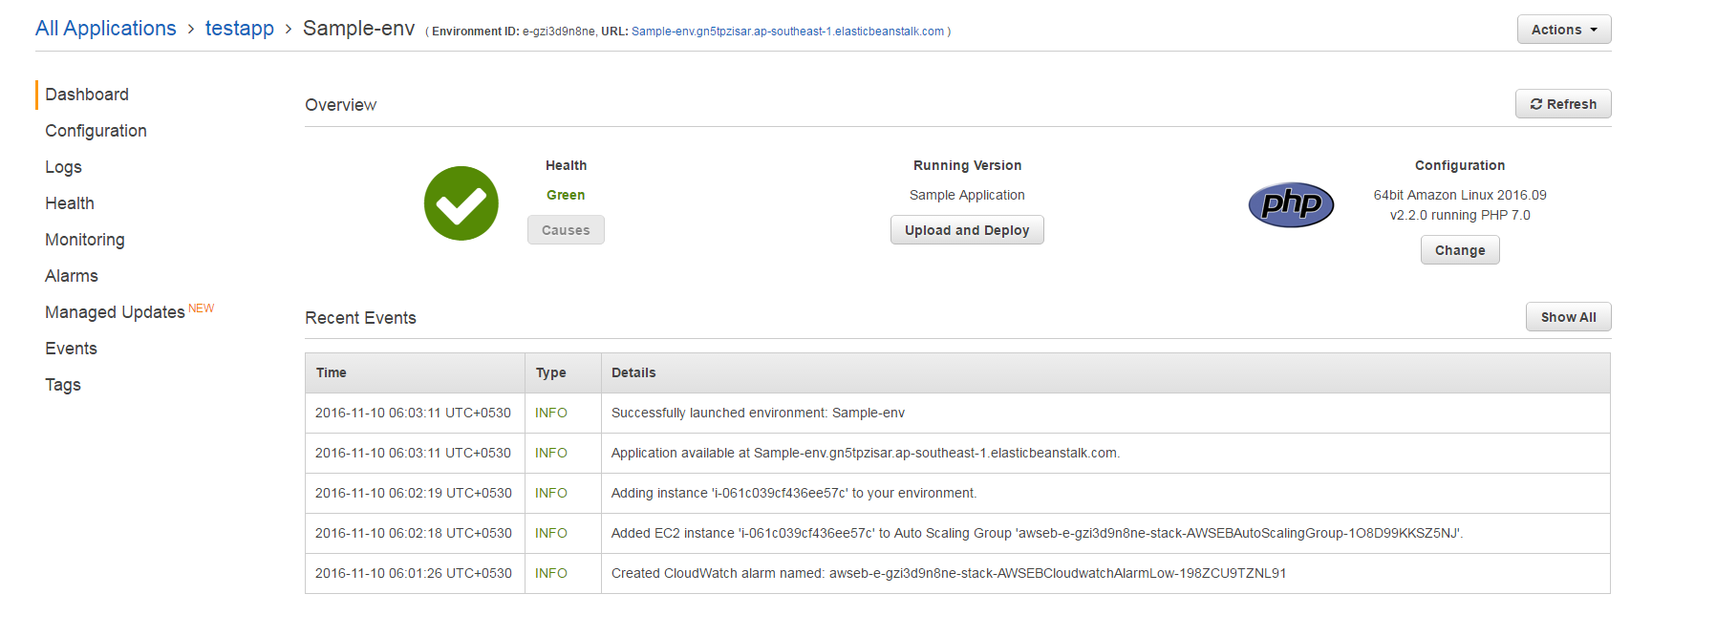

**Click on the url next Environment ID to see the application running .**

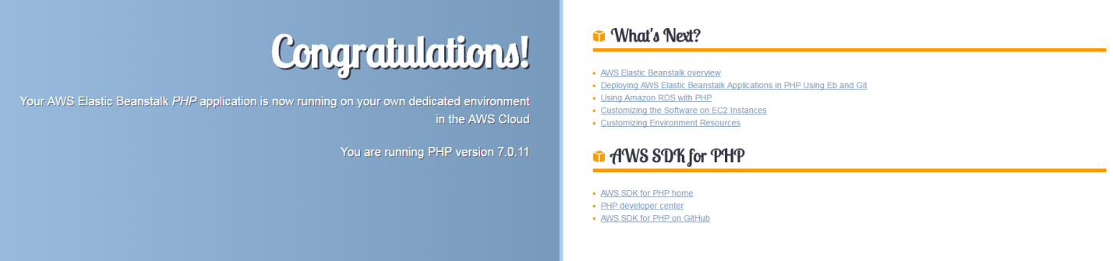

**Click on Services in a new tab 🡪 EC2 -- > EC2 instance running with Elastic bean stalk**

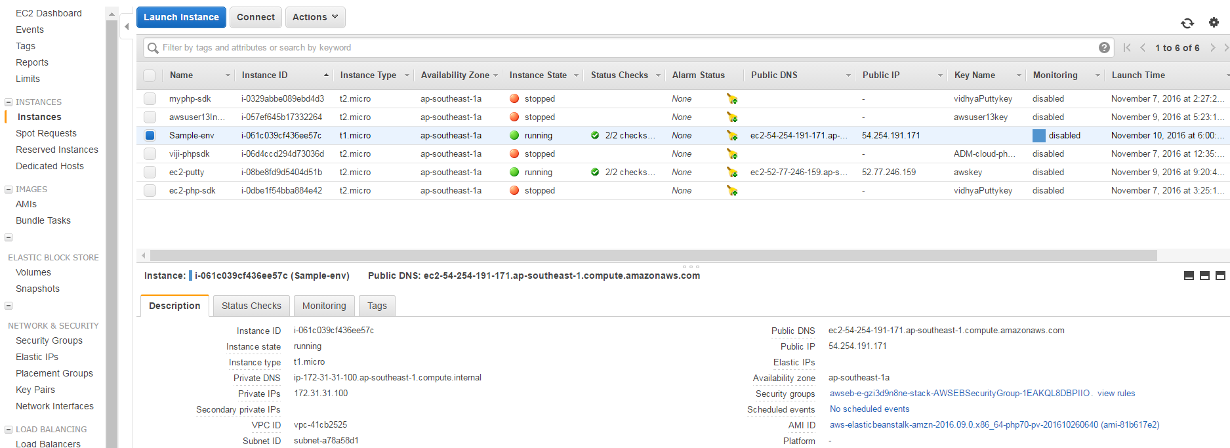

**Navigate to other tabs like monitoring , logs, alarms ,events to track the flow .**